W̱SÁNEĆ Leadership Council - Youth Employment Opportunity | 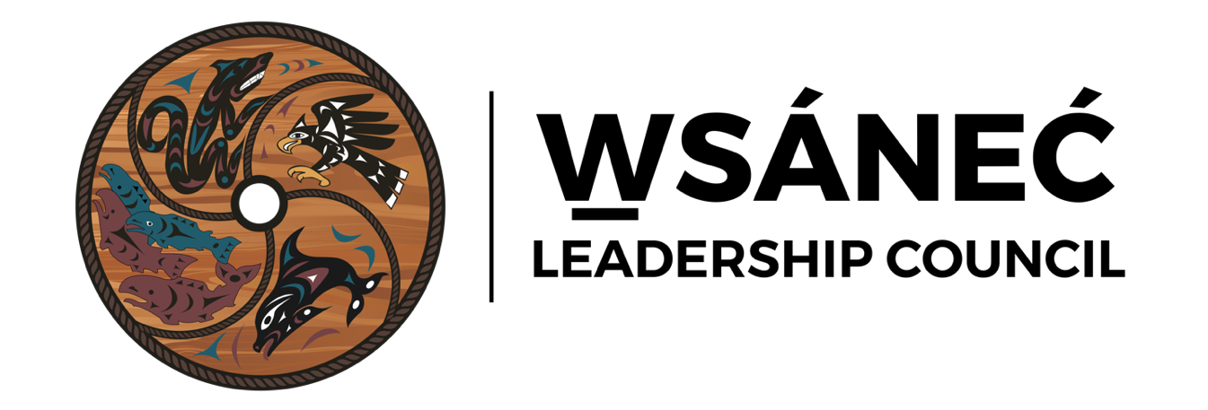
Job Description: Youth Reef Net Worker
Date Posted: June 13, 2024
Due Date: June 28, 2024, 2:00 PM
Application Details: Please send resume and cover letter to Marla Sampson, Office Manager (marla.sampson@wsanec.com) by due date

JOB DESCRIPTION

As an organization focused on self-determination, The W̱SÁNEĆ Leadership Council promotes the W̱SÁNEĆ culture, traditional practices, and language, including the original W̱SÁNEĆ management of the environment as meant to be. The WLC also seeks to promote sustainable and equitable development of resources within W̱SÁNEĆ Territory. One of the projects the WLC is currently facilitating to fulfill this focus is the W̱SÁNEĆ Youth SX̱OLE (Reef Net) Project.

The W̱SÁNEĆ Youth Reef Net Worker will work closely and under the direction of knowledge, holders to learn the specific knowledge to construct the SX̱OLE. Once the Reef Net construction is complete, the successful youth candidates will set the SX̱OLE at a SWALET (Reef Net Location) to be determined at a site within the Gulf Islands.

The successful candidates will need to be excited and interested in gaining this specialized knowledge, respectful of a learning environment, and willing to learn.
The W̱SÁNEĆ Youth Reef Net Worker will work closely and under the direction of knowledge holders to learn the specific knowledge to construct the SX̱OLE. Once the construction of the Reef Net is complete, the successful youth candidates will then set the SX̱OLE at a SWALET (Reef Net Location) to be determined at a site within Gulf Islands.

The successful candidates will need to be excited and interested in gaining this special knowledge. Respectful of a learning environment and willing to learn.

DUTIES

- Participate in learning sessions lead by knowledge holders
- Canoe and paddling training sessions
- Water Safety Training
- Hands on Constructing a SX̱OLE
- 3-5 day camp during SX̱OLE Set
- Day boat trips in the Territory

JOB REQUIREMENTS

- W̱SÁNEĆ Youth between the ages of 15-28 years old
- A willingness to learn
- A willingness to paddle and be on a travel canoe on the water
- Safety Training, First Aid an asset

